LAB REPORT # 01


Spring 2026
CSE-L Embeded Systems Lab
Submitted by: Ayesha Fayyaz
Registration number: 22PWCSE2123
Semester: 8th
Section: B

Student Signature: ______________

Submitted to:
Engr. Muhammad Shahzad
(February 17, 2025)

Department of Computer Systems Engineering
University of Engineering and Technology, Peshawar

LAB 1
INTRODUCTION TO EMBEDDED SYSTEMS AND ARDUINO ENVIRONMENT
Objectives
- To understand the basic concept of embedded systems.
- To get familiar with the Arduino hardware and programming environment.
- To learn how to write and upload a simple Arduino program.
- To simulate an Arduino circuit using online Tinkercad software.
- To control an LED using digital output pins of Arduino.
Theory
An embedded system is a specialized computer system designed to perform a specific task within a larger system. It consists of a microcontroller or microprocessor along with software and hardware components.
Arduino is an open-source embedded development platform that includes:
- A microcontroller board (Arduino Uno)
- An Integrated Development Environment (IDE) for writing and uploading programs
In Arduino, digital pins can be configured as INPUT or OUTPUT. An LED can be controlled by setting the pin HIGH (ON) or LOW (OFF). The delay() function is used to pause program execution for a specified time in milliseconds.
Tinkercad is an online simulation tool that allows users to design and test Arduino circuits without physical hardware.
Circuit Diagram
- Software Used: Online Tinkercad
- Components:
  - Arduino Uno
  - Built-in LED (connected internally to Pin 13)

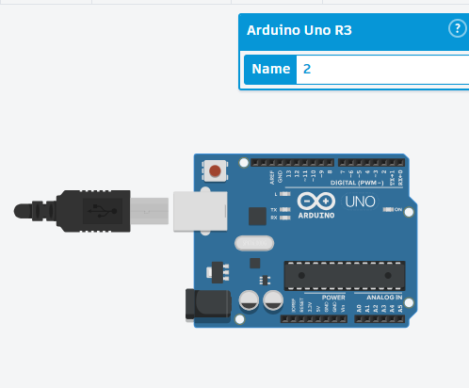
Algorithm
- Start the program.
- Initialize the built-in LED pin as OUTPUT.
- Turn the LED ON.
- Wait for 2000 milliseconds.
- Turn the LED OFF.
- Wait for 2000 milliseconds.
- Repeat the process continuously.
Source Code
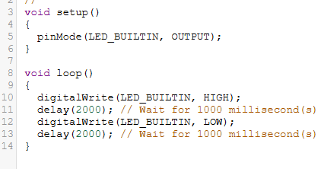
Procedure
- Open a web browser and go to the Tinkercad website.
- Create a new Arduino circuit project.
- Place an Arduino Uno board in the workspace.
- Use the built-in LED connected to pin 13.
- Write the LED blinking program in the code editor.
- Start the simulation.
- Observe the LED blinking behavior.
Results / Observations
- The built-in LED turned ON for 2 seconds and then turned OFF for 2 seconds.
- The LED continued blinking repeatedly throughout the simulation.
- The program executed successfully without any errors in Tinkercad.
